/*
* HelloWorld.cpp
*
* Created by Noah Greer on 9/30/09.
* Class: CS210
* Instructor: Craig Niiyama
*
* Displays the text "Hello, World!" and exits.
*
*/

#include <iostream> // include standard library
using namespace std; // use standard namespace

int main() // start main function that takes no arguments and returns an int
{

cout << "Hello, World!" << endl; // display "Hello, World!" and end the line

return 0; // exit and return control to the user

}
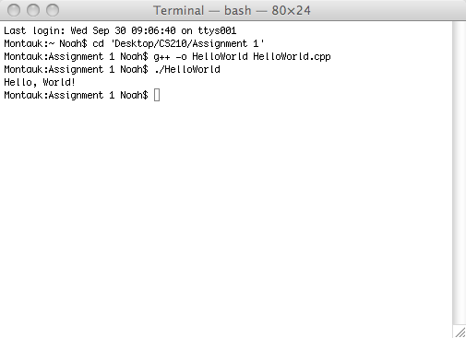
/*
* TemperatureConversion.cpp
*
* Created by Noah Greer on 9/30/09.
* Class: CS210
* Instructor: Craig Niiyama
*
* Asks user for a temperature in Fahrenheit converts that number into Celsius and displays the value.
*
*/

#include <iostream>
using namespace std;

float fahrToCelsius(int Fahrenheit); // Prototype for fahrToCelsius which will take the number that the user gives as the temperature in Fahrenheit

int main()
{

int Fahrenheit; // input - the temperature in Fahrenheit

cout << "Please enter the temperature in Fahrenheit: "; // Prompts user for temperature in Fahrenheit to be converted
cin >> Fahrenheit; // captures user input
cout << "The temperature in Celsius is: " << fahrToCelsius(Fahrenheit) << endl;

}

float fahrToCelsius(int Fahrenheit)
{

return (5.0/9.0) * (Fahrenheit - 32);

}
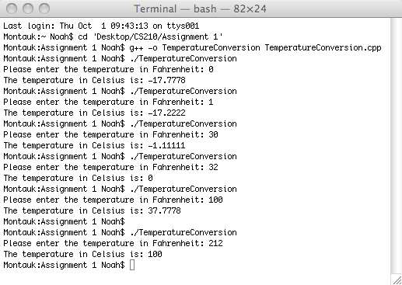
/*
* xy.cpp
*
* Created by Noah Greer on 9/30/09.
* Class: CS210
* Instructor: Craig Niiyama
*
* Collects two numbers and finds their sum, difference, product, and quotient. Then displays the results.
*
*/

#include <iostream> // include the standard library
using namespace std; // use the standard namespace

int main() // Begining of main function
{

int x, y, // input - two variables
sum, // output - the sum of x and y
difference, // output - the difference of x and y
product; // output - the product of x and y
float quotient; // output - the product of x and y

/* Prompt user for two numbers and put them in x and y */
cout << endl << "Enter a numeric value for x: ";
cin >> x;
cout << "Enter a numeric value for y: ";
cin >> y;

/* Perform sum, difference, product, and quotient opperations on x and y */
sum = x + y;
difference = x - y;
product = x * y;
quotient = (x * 1.0) / (y * 1.0);

/* Display the results of the previous operations */
cout << endl << "The sum of x and y is: " << sum << endl; // display the sum of x and y
cout << "The difference of x and y is: " << difference << endl; // display and difference of x and y
cout << "The product of x and y is: " << product << endl; // display the product of x and y
cout << "The quotient of x and y is: " << quotient << endl << endl; // display the quotient of x and y

return 0;

}
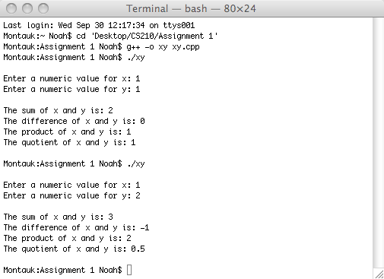
/*
* 1k1m.cpp
*
* Created by Noah Greer on 9/30/09.
* Class: CS210
* Instructor: Craig Niiyama
*
* Reads a number between 1000 and 1000000. Then, recalls the number with commas inserted every three digits.
*
*/

#include <iostream>
using namespace std;

int main()
{

const int MAX_VALUE = 1000000, // define the maximum of the range for input
MIN_VALUE = 1000; // define the minimum of the range for input

int number = 0; /* input - the number to be tested if its between 1000 and 1000000.
* Then, formatted and displayed with commas.
* Set to a starting value of 0 so the first while statement will be satisfied.
*/
int chunk1, chunk2; // output - two chunks of digits to have a comma placed between them

// check that the input is a number between 1000 and 1000000
while(number > MAX_VALUE || number < MIN_VALUE)
{
cout << "Enter a number between 1000 and 1000000: ";
cin >> number;
if(number > MAX_VALUE || number < MIN_VALUE)
{
cout << "Your number was not between 1000 and 1000000." << endl;
}
}

// If the number is the maximum value, then just print it already formatted. No calculation required.
if(number == MAX_VALUE)
{
cout << "Your number was: 1,000,000" << endl;
}

/* if the number is between the minimum and the maximum,
* then divide the number by 1000 to get the number of thousands, ten-thousands, and hundred-thousands and store it in chunk1
* then divide the number by 1000 and take the remainder to get the ones, tens, and hundreds places and put it in chunk2
* use printf to print chunk1
* then print chunk2 at least three digits wide and with zeros as padding
* so that a number like 12099 doesn't get displayed as 12,99 or a number like 12,001 doesn't get displayed as 12,1
*/
if(number < MAX_VALUE && number >= MIN_VALUE)
{
chunk1 = number / 1000;
chunk2 = number % 1000;
printf("Your number was: %d,%03d\n", chunk1, chunk2);
}

return 0;

}
